- Introduction

  - What is Cryptocurrency ???

Cryptocurrency is a form of payment that can be exchanged online for goods and services. ... Cryptocurrencies work using a technology called blockchain. Blockchain is a decentralized technology spread across many computers that manages and records transactions. A cryptocurrency, crypto-currency, or crypto is a collection of binary data which is designed to work as a medium of exchange wherein individual coin ownership records are stored in a ledger which is a computerized database using strong cryptography to secure transaction records, to control the creation of additional coins, and to verify the transfer of coin ownership. Some crypto schemes use validators to maintain the cryptocurrency. Typically a blockchain, that serves as a public financial transaction database. A logo for Bitcoin, the first decentralized cryptocurrency Bitcoin, first released as open-source software in 2009, is the first decentralized cryptocurrency. since the release of bitcoin, many other cryptocurrencies have been created . A cryptocurrency is a digital or virtual currency that is secured by cryptography, which makes it nearly important to counterfeit or double spend .Many cryptocurrencies are decentralized networks based on blockchain technology. A distributed ledger enforced by a disparate network of computer.


Figure 1: cryptocurrencies

1.2. Some key points about cryptocurrency

- A cryptocurrency is a form of digital asset based on a network that is distributed across a large number of computer. This decentralized structure allow them to exit outside the control of government and central authorities
- The word cryptocurrency is derived from the encryption techniques which are used to secure the network.
- Block chain, which are organizational methods got ensuring. the integrity of transactional data, are an essential components of many cryptocurrencies.
- Cryptocurrencies face criticsm for a number of reason, including their use for illegal activities, exchange rate volatility and vulnerabilities of the infrastructure underlying them. However they also have been praised for their portability, divisibility, inflation, resistance and transparency.

- Types of Cryptocurrency

- 5 most common types of cryptocurrency are =
- Bitcoin = The first blockcoin based cryptocurrency was bitcoin which still remains the most popular and most valuable. Bitcoin was launched in 2009 by an individual or group know by the pseudonym “ Satoshi Nakamoto” as August 2021 there were over 18.8 million bitcoin in circulation with a total market cap of around $858.9 billion.

Figure 2 Bitcoin
- Ethereum = Ethereum is a decentralized, open-source blockchain with smart contract functionality. Ether is the native cryptocurrency of the platform. Amongst cryptocurrencies, Ether is second only to Bitcoin in market capitalization.


Figure 3. Ethereum
- Litecoin =Litecoin was designed to be used for cheaper transactions, and to be more efficient for everyday use. In comparison, bitcoin was being used more as a store of value for long-term purposes. The coin limit market cap is much higher on litecoin than bitcoin, and the mining process far quicker.

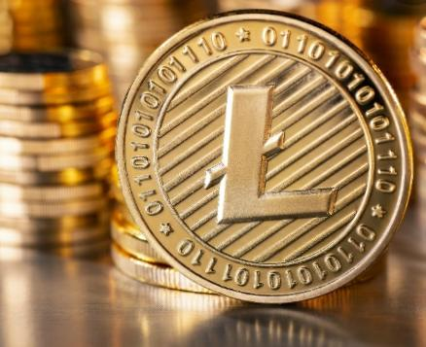
Figure 4 Litecoin

- Namecoin= Namecoin is a cryptocurrency originally forked from bitcoin software. It is based on the code of bitcoin and uses the same proof-of-work algorithm. Like bitcoin, it is limited to 21 million coins.

Figure 5 Namecoin

- Peercoin =Peercoin is an alternative cryptocurrency launched in August 2012 that is based on the Bitcoin framework. ... Peercoin was created by the software developers Sunny King and Scott Nadal.

Figure 6 peercoin
3.Advantage of Cryptocurrency
There are several advantages to using Bitcoin for transactions. However, the two main advantages of using the cryptocurrency are its peer-to-peer focus that removes intermediaries and its pseudonymous design that eliminates the need for identification information for both parties. Both characteristics expedite transactions and remove unnecessary steps for transactions. Bitcoin transactions do not involve fees or service charges using third-party intermediaries. However, users do have to pay Bitcoin’s blockchain network fees to conduct the transactions.

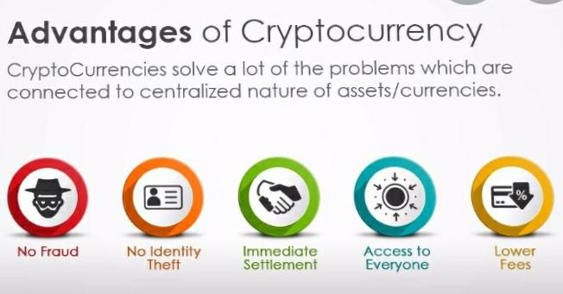
Figure 7 Advantage of Cryptocurrency

4.Disvantage of cryptocurrency
- It is possible to lose your virtual wallet or delete your currency. There have also been thefts from websites that let you store your cryptocurrency remotely.
- The value of cryptocurrencies such as Bitcoins can change significantly, so some people don't feel it is safe to turn 'real' money into Bitcoins.
- The cryptocurrency market is not regulated by the Financial Conduct Authority (FCA) so there are no rules in place to protect your business.
- If companies or consumers move to a new cryptocurrency from you or stop using digital currencies entirely, it could lose value and become worthless.
- Cryptocurrency exchanges are vulnerable to cyber attacks, which could lead to an irreparable loss of your investment.

6. Summary and Future Work
cryptocurrency (or “crypto”) is a digital currency that can be used to buy goods and services, but uses an online ledger with strong cryptography to secure online transactions. Much of the interest in these unregulated currencies is to trade for profit, with speculators at times driving prices skyward. Many companies have issued their own currencies, often called tokens, and these can be traded specifically for the good or service that the company provides. Think of them as you would arcade tokens or casino chips. You’ll need to exchange real currency for the cryptocurrency to access the good or service.
Cryptocurrencies work using a technology called blockchain. Blockchain is a decentralized technology spread across many computers that manages and records transactions. Part of the appeal of this technology is its security

References
I take help from internet from the following websites links have been used in the competition of this report
- www.nerdwallet.com
- www.investopedia.com
- www.ndtv.com
- www.sofi.com
And our subject teacher Mr. Praveen Joshi Sir Help us a lot for completing this report ……

